Skip to main content

Global Knowledge

Top of Form

Bottom of Form

Screenshots

Module 9: Implementing failover clustering with Windows Server Hyper-V

Lab: Implementing failover clustering with Windows Server Hyper-V

**Scenario**

The initial deployment of VMs on Hyper-V has been successful for Adatum Corporation. As a next step in VM deployment, Adatum is considering ways to ensure that the services and applications deployed on the VMs are highly available. As part of the implementation of high availability for most network services and applications, Adatum is also considering options for making the VMs that run on Hyper-V highly available. As one of the senior network administrators at Adatum, you are responsible for integrating Hyper-V with failover clustering to ensure that the VMs deployed on Hyper-V are highly available. You are responsible for planning the VM and storage configuration, and for implementing the VMs as highly available services on the failover cluster. You have limited hardware; so, to facilitate testing before implementation in your production environment, you will enable nested virtualization to test clustering two Hyper-V Hosts.

Exercise 1: Configuring virtual environment

**Scenario**

To test failover clustering for Hyper-V clusters, you have decided to install the Hyper-V role on one physical server, implement nested virtualization on two VMs and install Hyper-V on the two nested VMs.

The main tasks for this exercise are as follows:

* Configure physical host, VMs, and nested virtualization.
* Install Hyper-V on nested virtualization hosts.

Task 0: Create iSCSI shared storage

1. Switch to [**LON-STOR1**](urn:gd:lg:a:select-vm) and send the [**CTRL+ALT+DEL**](urn:gd:lg:a:send-vm-key-combo) command and login as **[Adatum\AdatumAdmin](urn:gd:lg:a:send-vm-keys" \o "Paste text into VM)** with the password [**Pa55w.rd**](urn:gd:lg:a:send-vm-keys)
2. Right click **Start** and select **Windows PowerShell (Admin)**.

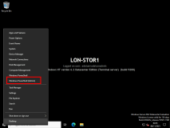

1. Run the following command to install the File Services and iSCSI Target Server roles.
2. Install-WindowsFeature File-Services,FS-iSCSITarget-Server -IncludeManagementTools

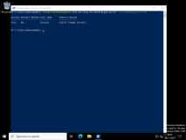

1. Click **Start** and select **Server Manager**.

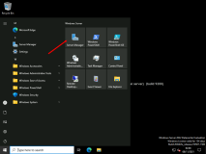

1. In Server Manager, in the **Navigation** pane, click **File and Storage Services**.

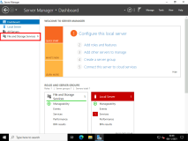

1. In the **File and Storage Services** pane, click **iSCSI**.

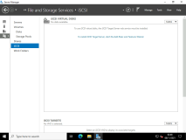

1. In the **iSCSI VIRTUAL DISKS** pane, click **TASKS**, and then, in the **TASKS** drop-down list, select **New iSCSI Virtual Disk**.

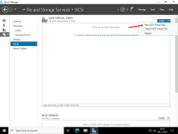

1. In the **New iSCSI Virtual Disk Wizard**, on the **Select iSCSI virtual disk location** page, under **Storage location**, click **E:**, and then click **Next**.

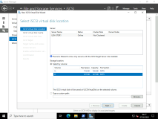

1. On the **Specify iSCSI virtual disk name** page, in the **Name** text box, type **[iSCSIDisk](urn:gd:lg:a:send-vm-keys" \o "Paste text into VM)** and then click **Next**.

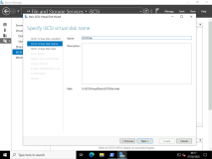

1. On the **Specify iSCSI virtual disk size** page, in the **Size** text box, type [**50**](urn:gd:lg:a:send-vm-keys), ensure that **GB** is selected in the drop-down list, and then click **Next**.

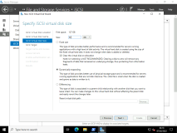

1. On the **Assign iSCSI target** page, click **New iSCSI target**, and then click **Next**.

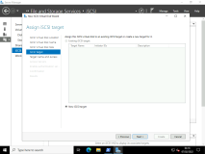

1. On the **Specify target name** page, in the **Name** text box, type **[lon-hv-hosts](urn:gd:lg:a:send-vm-keys" \o "Paste text into VM)** and then click **Next**.

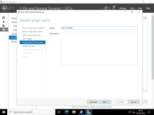

1. On the **Specify access servers** page, click **Add**.

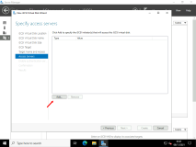

1. In the **Select a method to identify the initiator** dialog box, click **Enter a value for the selected type**, and in the **Type** drop-down list, select **IP Address**. In the **Value** text box, type [**172.16.0.101**](urn:gd:lg:a:send-vm-keys) and then click **OK**.

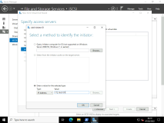

1. On the **Specify access servers** page, click **Add**.

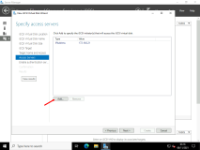

1. In the **Select a method to identify the initiator** dialog box, click **Enter a value for the selected type**, and then, in the **Type** drop-down list, select **IP Address**. In the **Value** box, type [**172.16.0.102**](urn:gd:lg:a:send-vm-keys) and then click **OK**.
2. On the **Specify access servers** page, click **Next**.
3. On the **Enable Authentication** page, click **Next**.

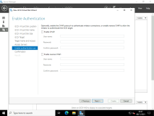

1. On the **Confirm selections page**, click **Create**.

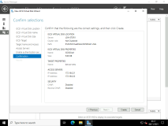

1. On the **View results** page, wait until creation is complete, and then click **Close**.

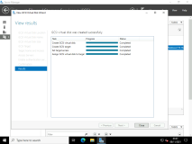

1. Select **Tasks** > **New iSCSI Virtual Disk**.

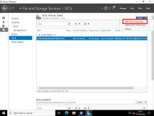

1. In the **New iSCSI Virtual Disk Wizard**, on the **Select iSCSI virtual disk location** page, under **Storage location**, click **E:**, and then click **Next**.



1. On the **Specify iSCSI virtual disk name** page, in the **Name** text box, type **[CusterVMsDisk](urn:gd:lg:a:send-vm-keys" \o "Paste text into VM)** and then click **Next**.

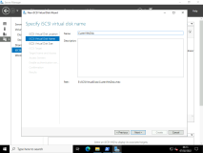

1. On the **Specify iSCSI virtual disk size** page, in the **Size** text box, type [**50**](urn:gd:lg:a:send-vm-keys), ensure that **GB** is selected in the drop-down list, and then click **Next**.



1. On the **Assign iSCSI target** select the **lon-hv-hosts** existing target, and then click **Next**.

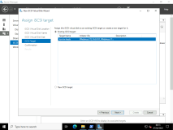 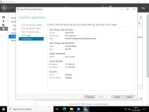

1. On the **Confirm selections page**, click **Create**.



1. On the **View results** page, wait until creation is complete, and then click **Close**.

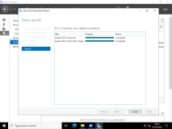

1. Repeat the steps to create a final iSCSI disk called **[QuorumDisk](urn:gd:lg:a:send-vm-keys" \o "Paste text into VM)**.

Task 1: Configure VMs and nested virtualization

1. Switch to [**LON-HV2**](urn:gd:lg:a:select-vm) and send the [**CTRL+ALT+DEL**](urn:gd:lg:a:send-vm-key-combo) command and login as **[Adatum\AdatumAdmin](urn:gd:lg:a:send-vm-keys" \o "Paste text into VM)** with the password [**Pa55w.rd**](urn:gd:lg:a:send-vm-keys)
2. On [**LON-HV2**](urn:gd:lg:a:select-vm), right click **Start**, and then select **Windows PowerShell (Admin)**.

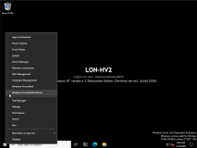

1. In the **Windows PowerShell** window, type the following command, and then press Enter:
2. Install-WindowsFeature -Name Hyper-V,Hyper-V-Tools,Hyper-V-PowerShell -Restart

**Note:** The machine will restart a couple of times.

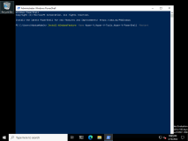

1. Sign into [**LON-HV2**](urn:gd:lg:a:select-vm) by sending the [**CTRL+ALT+DEL**](urn:gd:lg:a:send-vm-key-combo) command and login as **[Adatum\AdatumAdmin](urn:gd:lg:a:send-vm-keys" \o "Paste text into VM)** with the password [**Pa55w.rd**](urn:gd:lg:a:send-vm-keys)
2. Open **File Explorer**, and then browse to **D:\**.

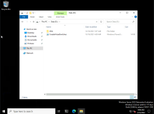

1. Run the following scripts by right clicking the files and selecting **Run with PowerShell** and answering Yes [**Y**](urn:gd:lg:a:send-vm-keys) to the Execution Policy. This script creates switches required for this lab:

**CreateVirtualSwitches.ps1**

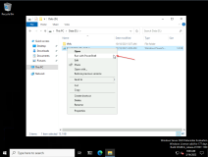

1. Open **Server Manager**, click **Tools**, and then click **Hyper-V Manager**.

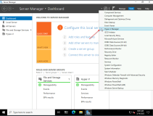

1. In the left pane, select **LON-HV2**.

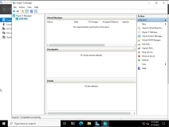

1. Sign into [**LON-HV1**](urn:gd:lg:a:select-vm) by sending the [**CTRL+ALT+DEL**](urn:gd:lg:a:send-vm-key-combo) command and login as **[Adatum\AdatumAdmin](urn:gd:lg:a:send-vm-keys" \o "Paste text into VM)** with the password [**Pa55w.rd**](urn:gd:lg:a:send-vm-keys)
2. Open **File Explorer**, and then browse to [**D:\**](urn:gd:lg:a:send-vm-keys).
3. Run the following scripts by right clicking the files and selecting **Run with PowerShell** and answering Yes [**Y**](urn:gd:lg:a:send-vm-keys) to the Execution Policy. This script creates switches required for this lab:

**CreateVirtualSwitches.ps1**

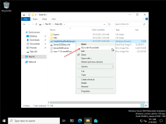

1. Open **Server Manager**, click **Tools**, and then click **Hyper-V Manager**.

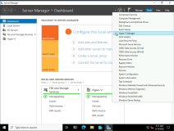

1. In the left pane, select **LON-HV1**.

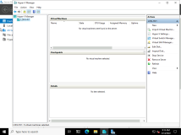

1. In the Actions pane select **Import Virtual Machine**.

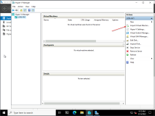

1. On the **Import Virtual Machine - Before you Begin** screen click **Next**.
2. On the **Import Virtual Machine - Locate Folder** screen enter [**D:\Export\LON-NVHOST1**](urn:gd:lg:a:send-vm-keys) and click **Next**.

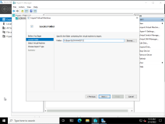

1. On the **Import Virtual Machine - Select Virtual machine** screen click **Next**.

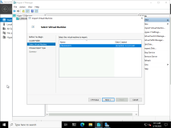

1. On the **Import Virtual Machine - Choose Import Type** screen click **Next**.

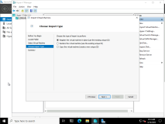

1. Finally, click **Finish**.

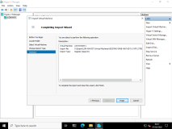

1. In the **Virtual Machines** pane, select **LON-NVHOST1**

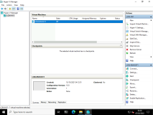

1. Right click the **Start** menu and select **Windows PowerShell (Admin)** and then run the following commands to enable nested virtualization on **LON-NVHOST1**
2. Set-VMProcessor -VMName LON-NVHOST1 -ExposeVirtualizationExtensions $true
3. Get-VMNetworkAdapter -VMName LON-NVHOST1 | Set-VMNetworkAdapter -MacAddressSpoofing On
4. Set-VMMemory LON-NVHOST1 -DynamicMemoryEnabled $false

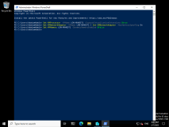

Task 2: Install Hyper-V on nested virtualization hosts

1. If not already open, click **Server Manager**, click **Tools**, and then click **Hyper-V Manager**.
2. In the **Virtual Machines** pane, select **LON-NVHOST1**
3. In the **Actions** menu, click **Start**.

**Note:** Before continuing ensure all the virtual machines are fully booted.

1. If you closed the **Windows PowerShell** window on **LON-HV1**, click **Start**, right-click **Windows PowerShell**, and then click **Run as Administrator**.
2. To open a **PSSession** utilizing **Windows PowerShell Direct**, at the **Windows PowerShell** command prompt, type the following command, and then press Enter:
3. Enter-PSSession -VMName LON-NVHOST1

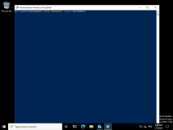

1. In the **Credentials request** dialog box, in the **Username** text box, type [**Administrator**](urn:gd:lg:a:send-vm-keys), and in the **Password** text box, type [**Pa55w.rd**](urn:gd:lg:a:send-vm-keys), and then press Enter.

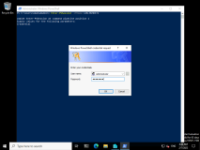

1. To install **Hyper-V**, type the following command at the **Windows PowerShell** command prompt, and then press Enter:
2. Install-WindowsFeature -Name Hyper-V,Hyper-V-Tools,Hyper-V-Powershell -Restart

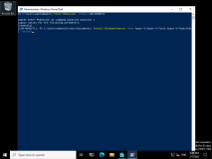

1. Wait until the installation completes. Type the following command at the **Windows PowerShell** command prompt, and then press Enter:
2. **Exit**

**Note:** If this generates the error "Command 'Exit' was not run as the session in which it was intended to run was either closed or broken," ignore this error. This occurs because the PowerShell remote connection is disconnected due to the Vitual Machine being rebooted and installing the Hyper-V role.

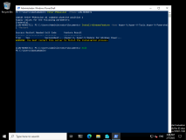

**Results** : After completing this exercise, you should have successfully imported VMs and enabled nested virtualization on **LON-NVHOST1**.

Exercise 2: Configuring a failover cluster for Hyper-V

**Scenario**

The initial deployment of VMs on Hyper-V is very successful for Adatum. As a next step in the deployment, Adatum is considering ways to ensure that the services and applications deployed on the VMs are highly available. As part of the implementation of high availability for most network services and applications, Adatum also is considering options for making the VMs that run on Hyper-V highly available. You are responsible for planning the VM and storage configuration, and for implementing the VMs as highly available services on the Failover Cluster.

The main tasks for this exercise are as follows:

1. Connect to the iSCSI target from both host machines.
2. Configure failover clustering on both host machines.
3. Configure disks for a failover cluster.

Task 1: Connect to the iSCSI target from both host machines

1. On [**LON-HV1**](urn:gd:lg:a:select-vm), click **Start**, click the **Server Manager** icon, and then in the **Server Manager** window click **Tools**, and then click **iSCSI Initiator**.

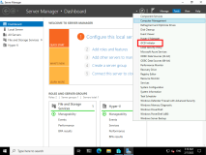

1. At the **Microsoft iSCSI** prompt, click **Yes**.

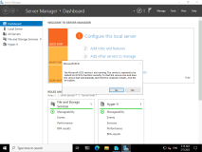

1. Click the **Discovery** tab.

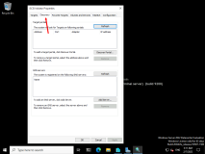

1. On the **Discovery** tab, click **Discover Portal**.

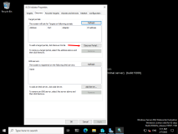

1. In the **IP address or DNS name** text box, type [**172.16.0.201**](urn:gd:lg:a:send-vm-keys), and then click **OK**.

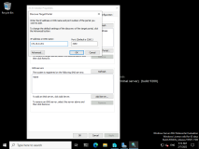

1. Click the **Targets** tab.
2. In the **Discovered targets** list, click **iqn.1991-05.com.microsoft:lon-hv-hosts-target**, and then click **Connect**.

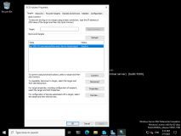

1. If not already selected, select **Add this connection to the list of Favorite Targets**, and then click **OK**.

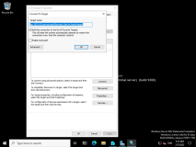

1. To close **iSCSI Initiator Properties** dialog box, click **OK**.
2. Switch to [**LON-HV2**](urn:gd:lg:a:select-vm).
3. On **LON-HV2**, open **Server Manager**, click **Tools**, and then click **iSCSI Initiator**.
4. In the **Microsoft iSCSI** dialog box, click **Yes**.
5. In the **iSCSI Initiator** dialog box, click the **Discovery** tab.
6. On the **Discovery** tab, click **Discover Portal**.
7. In the **IP address or DNS name** text box, type [**172.16.0.201**](urn:gd:lg:a:send-vm-keys), and then click **OK**.

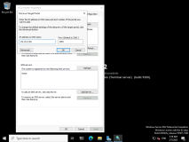

1. Click the **Targets** tab.
2. In the **Discovered targets** list, click **iqn.1991-05.com.microsoft:lon-hv-hosts-target**, and then click **Connect**.

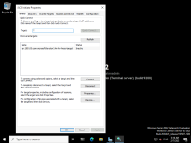

1. Select **Add this connection to the list of Favorite Targets**, and then click **OK**.

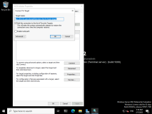

1. To close the **iSCSI Initiator Properties** dialog box, click **OK**.

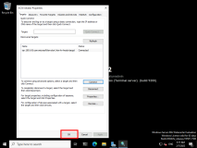

1. On [**LON-HV2**](urn:gd:lg:a:select-vm), in **Server Manager**, click **Tools**, and then click **Computer Management**.

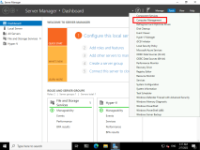

1. Expand **Storage**, and then click **Disk Management**.

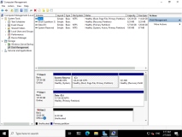

1. Right-click **Disk 3**, and then click **Online**.

**Note**: This is the first 50Gb iSCSI disk you created in Task 0

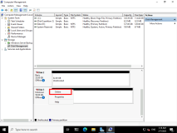

1. Right-click **Disk 3**, and then click **Initialize Disk**.

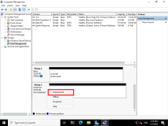

1. In the **Initialize Disk** dialog box, click **OK**.
2. Right-click the unallocated space next to **Disk 3**, and then click **New Simple Volume**.

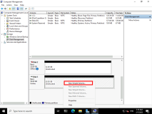

1. On the **Welcome** page, click **Next**.

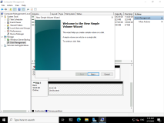

1. On the **Specify Volume Size** page, click **Next**.

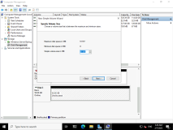

1. On the **Assign Drive Letter or Path** page, click **Next**.

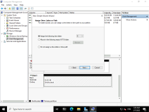

1. On the **Format Partition** page, in the **Volume label** text box, type **[ClusterDisk](urn:gd:lg:a:send-vm-keys" \o "Paste text into VM)**.

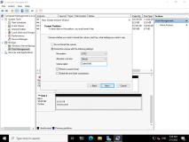

1. Select the **Perform a quick format** check box, click **Next**, and then click **Finish**.

**Note:** If a **Microsoft Windows** prompt appears to format the disk, click **Cancel**.

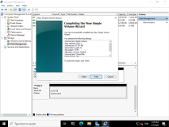

1. Repeat steps 22 through 30 for **Disk 2** and **Disk 4**. In step 29, use the following settings:
   * Disk 2 name: **[ClusterVMs](urn:gd:lg:a:send-vm-keys" \o "Paste text into VM)**
   * Disk 4 name: [**Quorum**](urn:gd:lg:a:send-vm-keys)

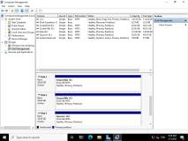

1. Switch to [**LON-HV1**](urn:gd:lg:a:select-vm)
2. On **LON-HV1** in **Server Manager**, click **Tools**, and then click **Computer Management**.
3. Expand **Storage**, and then click **Disk Management**.
4. Right-click **Disk Management**, and then click **Refresh**.

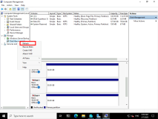

1. Right-click **Disk 2**, and then click **Online**.
2. Right-click **Disk 3**, and then click **Online**.
3. Right-click **Disk 4**, and then click **Online**.
4. Close the **Computer Management** console.

Task 2: Configure failover clustering on both host machines

1. On [**LON-HV1**](urn:gd:lg:a:select-vm), ensure that the **Server Manager** console is open.
2. In **Server Manager**, on the **Dashboard**, click **Add roles and features**.

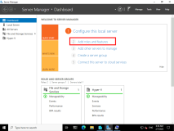

1. On the **Before you begin** page, click **Next**.

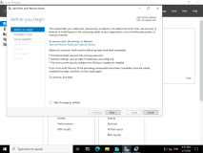

1. On the **Select installation type** page, click **Next**.

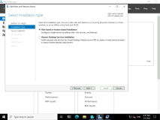

1. On the **Select destination server** page, ensure that **Select server from the server pool** is selected, and then click **Next**.

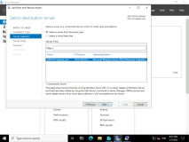

1. On the **Select server roles** page, click **Next**.

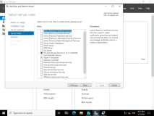

1. On the **Select features** page, in the **Features** list, click **Failover Clustering**. At the **Add features that are required for failover clustering** prompt, click **Add Features**, and then click **Next**.

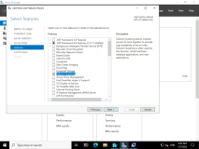

1. On the **Confirm installation selections** page, click **Install**.

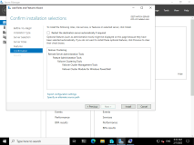

1. When installation is complete, click **Close**.

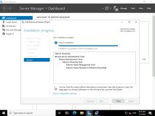

1. Switch to [**LON-HV2**](urn:gd:lg:a:select-vm).
2. Repeat steps 1 through 9 on **LON-HV2**.
3. Switch back to [**LON-HV1**](urn:gd:lg:a:select-vm)
4. On [**LON-HV1**](urn:gd:lg:a:select-vm), in **Server Manager**, click **Tools**, and then click **Failover Cluster Manager**.

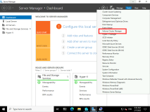

1. In **Failover Cluster Manager**, in the center pane, under **Management**, click **Create Cluster**.

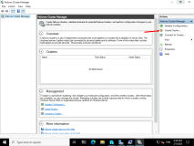

1. On the **Before You Begin** page of the **Create Cluster Wizard**, read the information, and then click **Next**.

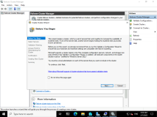

1. On the **Select Servers** page, in the **Enter server name** textbox, type [**LON-HV1**](urn:gd:lg:a:send-vm-keys), and then click **Add**. Again, in the **Enter server name** text box, type [**LON-HV2**](urn:gd:lg:a:send-vm-keys), and then click **Add**.

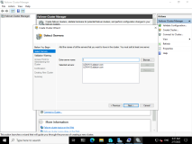

1. Verify the entries, and then click **Next**.
2. On the **Validation Warning** page, click **No. I don't require support from Microsoft for this cluster**, and then click **Next**.

**Note:** You are skipping validation to save some time in the lab. In a production environment, you should never skip cluster validation.

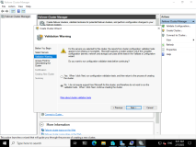

1. On the **Access Point for Administering the Cluster** page, in the **Cluster Name** text box, type **[VMCluster](urn:gd:lg:a:send-vm-keys" \o "Paste text into VM)**.
2. In the **Address** text box, type [**172.16.0.126**](urn:gd:lg:a:send-vm-keys), and then click **Next**.

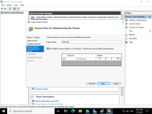

1. In the **Confirmation** dialog box, verify the information, clear the **Add all eligible storage to the cluster** option check box, and then click **Next**.

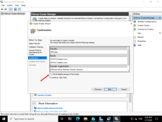

1. On the **Summary** page, click **Finish**.

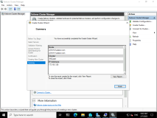

Task 3: Configure disks for a failover cluster

1. On [**LON-HV1**](urn:gd:lg:a:select-vm), in the **Failover Cluster Manager** console, expand **VMCluster.Adatum.com**, expand **Storage**, right-click **Disks**, and then click **Add Disk**.

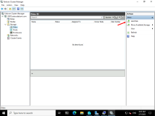

1. In the **Add Disks to Cluster** dialog box, verify that all disks are selected, and then click **OK**.

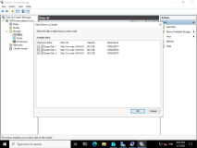

1. Click **Disks** in the left pane and verify that all disks display as **Available Storage** in **Failover Cluster Manager**.

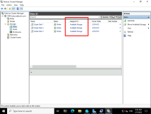

1. Click **Cluster Disk 1**, right-click that disk, and then click **Add to Cluster Shared Volumes**.
2. Right-click **VMCluster.adatum.com**, click **More Actions**, click **Configure Cluster Quorum Settings**, and then click **Next**.

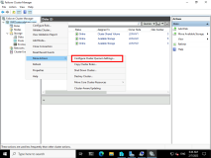

1. On the **Select Quorum Configuration Option** page, click **Use default quorum configuration**, and then click **Next**.

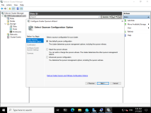

1. On the **Confirmation** page, click **Next**.

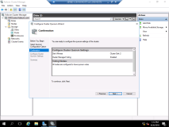

1. On the **Summary** page, click **Finish**.

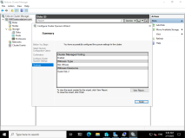

**Results**: After completing this exercise, you should have successfully configured the failover clustering infrastructure for Hyper-V.

Exercise 3: Configuring a highly available VM

**Scenario**

After you have configured the Hyper-V failover cluster, you want to add VMs as highly available resources. In addition, you want to evaluate Live Migration and test Storage Migration.

The main tasks for this exercise are as follows:

1. Move VM storage to the iSCSI target.
2. Configure the VM as highly available.
3. Failover VM.
4. Configure drain on shutdown.
5. Prepare for the next module.

Task 1: Move VM storage to the iSCSI target

1. Ensure that **LON-HV1** is the owner of the disk that you just assigned to **Cluster Shared Volume**. You can read the owner value in the **Owner Node** column. If that is not the case, then move the disk to **LON-HV1** before proceeding to step 2.

**Note:** To move the disk:

* + Right-click the disk, and then click **Move**.
  + Click **Select Node**, click **LON-HV1**, and then click **OK**.

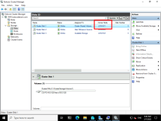

1. On [**LON-HV1**](urn:gd:lg:a:select-vm), on the desktop, on the taskbar, click the **File Explorer** icon.

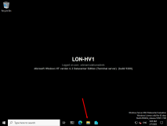

1. In **File Explorer**, expand drive **D:**, expand **Export**, expand **LON-VM1**, expand **Virtual hard Disks**.

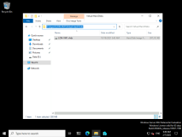

1. In the details pane, copy the **LON-VM1.vhdx** virtual hard disk file to the **C:\ClusterStorage\Volume1** location. You can do this by dragging and dropping the VHD file to the **C:\ClusterStorage\Volume1** location.

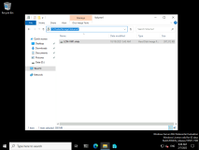

Task 2: Configure the VM as highly available

1. On [**LON-HV1**](urn:gd:lg:a:select-vm), in **Failover Cluster Manager**, click **Roles**, and then in the **Actions** pane, click **Virtual Machines**.

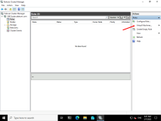

1. Click **New Virtual Machine**.
2. Select **LON-HV1** as the cluster node, and then click **OK**.

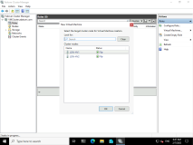

1. In the **New Virtual Machine Wizard**, on the **Before You Begin** page, click **Next**.

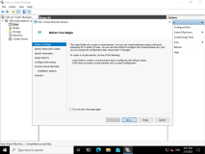

1. On the **Specify Name and Location** page, in the **Name** text box, type [**LON-VM1**](urn:gd:lg:a:send-vm-keys), click **Store the virtual machine in a different location**,and then click **Browse**.

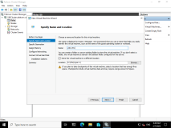

1. Browse to and select [**C:\ClusterStorage\Volume1**](urn:gd:lg:a:send-vm-keys), click **Select Folder**, and then click **Next**.

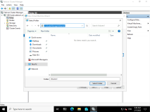

1. On the **Specify Generation** page, click **Generation 1**, and then click **Next**.

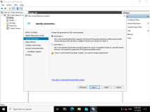

1. On the **Assign Memory** page, type [**1024**](urn:gd:lg:a:send-vm-keys), and then click **Next**.

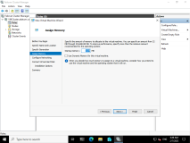

1. On the **Configure Networking** page, leave the selection as **Not Connected**, and then click **Next**.

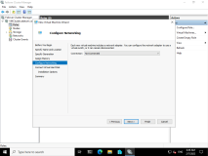

1. On the **Connect Virtual Hard Disk** page, click **Use an existing virtual hard disk**, and then click **Browse**.
2. Browse to [**C:\ClusterStorage\Volume1**](urn:gd:lg:a:send-vm-keys), click **LON-VM1.vhdx**, and then click **Open**.

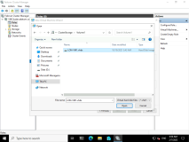

1. Click **Next**, and then click **Finish**. .

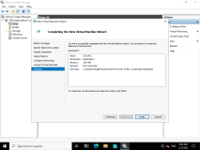

1. On the **Summary** page of the **High Availability Wizard**, click **Finish**.

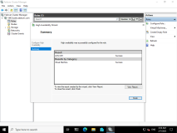

1. Right-click the **LON-VM1**, and then click **Settings**.

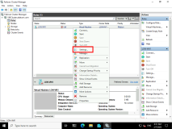

1. On **LON-HV1**, in the **Settings for LON-VM1** dialog box, in the navigation pane, expand **Processor**, and then click **Compatibility**.

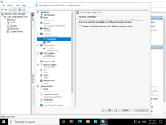

1. In the right pane, select the **Migrate to a physical computer with a different processor version** check box, and then click **OK**.

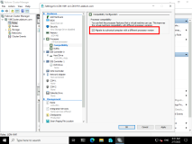

1. Right-click **LON-VM1**, and then click **Start**.

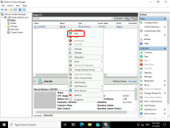

1. Ensure that the VM starts successfully.

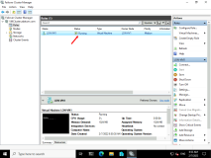

Task 3: Failover VM

1. On [**LON-HV2**](urn:gd:lg:a:select-vm), in the **Server Manager** console, click **Tools**, and then click **Failover Cluster Manager**.

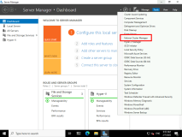

1. Expand **VMCluster.Adatum.com**, and then click **Roles**.

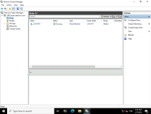

1. Right-click **LON-VM1**, click **Move**, click **Live Migration**, and then click **Select Node**.

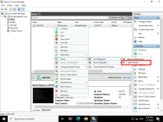

1. Click **LON-HV2**, and then click **OK**. Wait until the machine is migrated. You will see that the **Owner Node** column will change the value when migration completes.

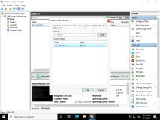

1. Right-click **LON-VM1**, and then click **Connect**.

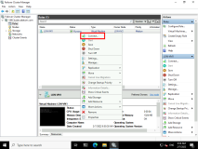

1. Ensure that you can access and operate the VM after it is migrated to another host.

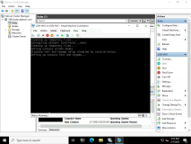

1. In **Failover Cluster Manager**, right click **LON-VM1**, and select **Shut Down**.

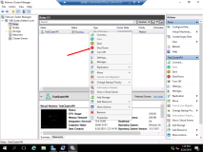

Task 4: Configure drain on shutdown

1. On [**LON-HV1**](urn:gd:lg:a:select-vm) right click the **Start** and select **Windows PowerShell (Admin)**.

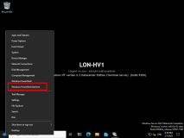

1. At the **Windows PowerShell** command prompt, type the following command, and then press Enter:
2. (Get-Cluster).DrainOnShutdown

**Note:** This should return a value of **1**

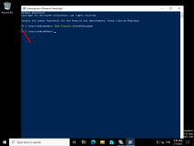

1. On [**LON-HV1**](urn:gd:lg:a:select-vm), restore the **Failover Cluster Manager** console.
2. Select **Roles** in **Failover Cluster Manager**.

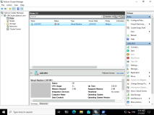

1. Click on **Windows Start**, select **Power**, and then select **Shut down**.
2. On the pop-up dialog box, select **Continue**.
3. Switch to [**LON-HV2**](urn:gd:lg:a:select-vm)
4. Observe **LON-VM1** live migrate to **LON-HV1** from **LON-HV2** before shutting down by monitoring the Failover Cluster Manager running on [**LON-HV2**](urn:gd:lg:a:select-vm).

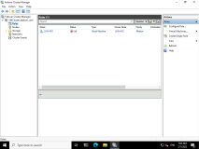

**Results**: After completing this exercise, you should have successfully configured the VM as highly available.

**Congratulations!** You have now completed this lab. To continue to the next lab click End Lab in the Tools Menu . If you wish to contiue with this lab at a later date ensure you save the lab environment rather than ending it.